MYSQL

Download & install: <https://dev.mysql.com/downloads/installer/>

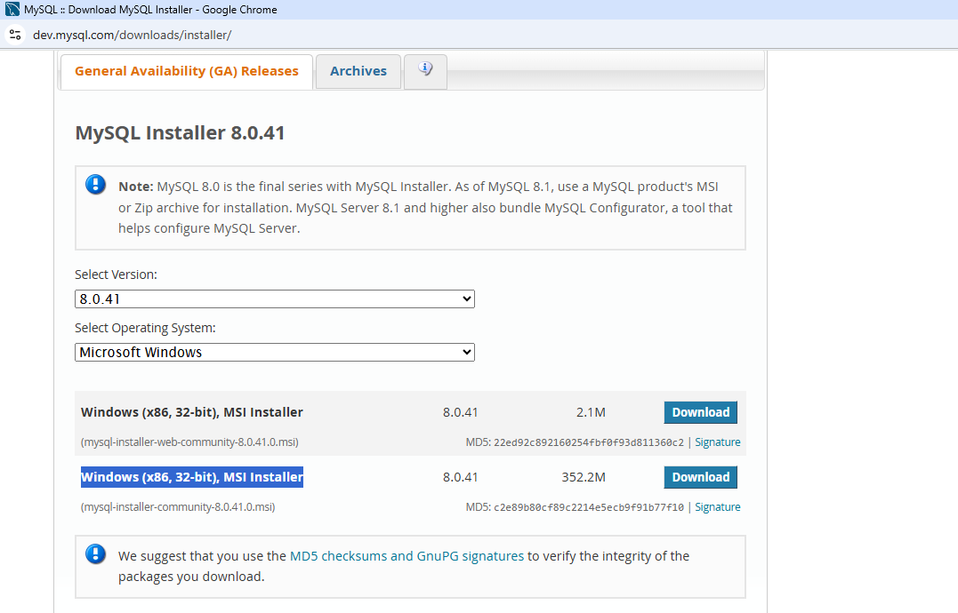

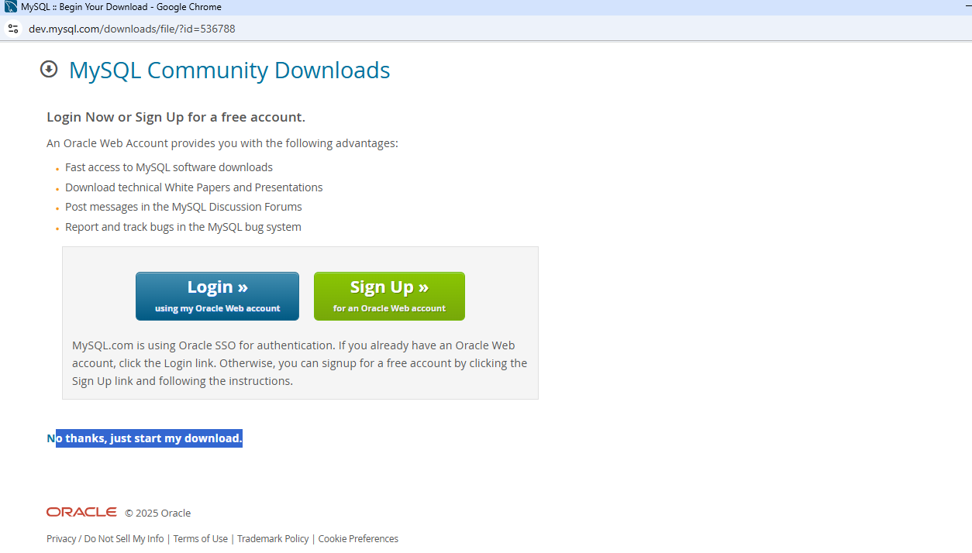

Select custom:

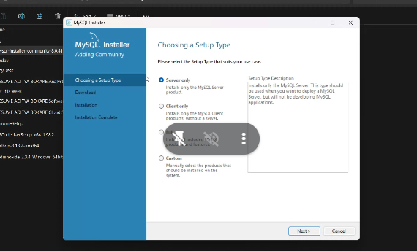

Click filter & select 64 bit

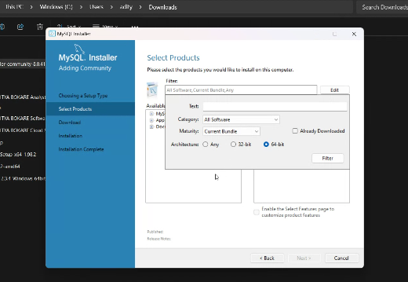

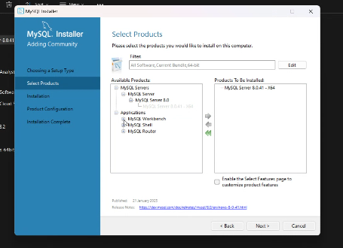

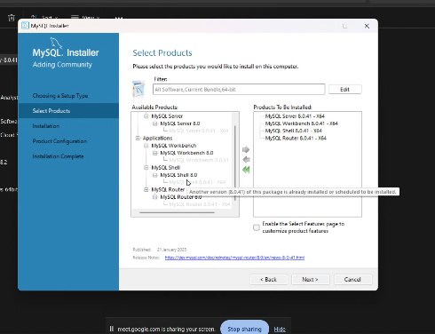

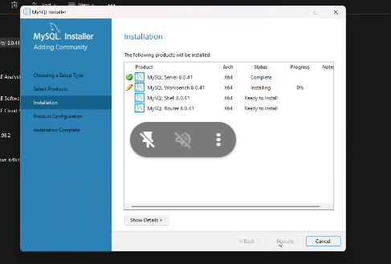

Set the password:

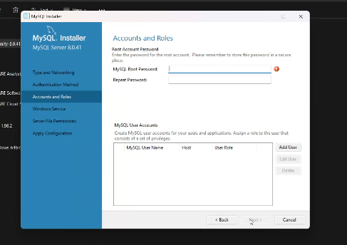:

Next-> next -🡪 execute-> finished

**Open Mysql Workbench:**

**Task: By using Mysql Workbench interface**

1. **Create database**
2. **Create table**
3. **Add some users in to table**

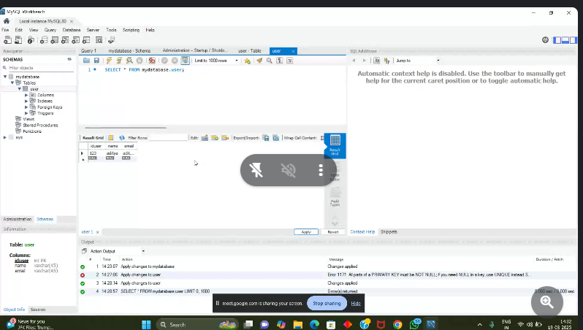

**Task: By using Mysql Workbench & sql queries**

1. Create database

CREATE DATABSE demo_db;

1. Create table

USE demo_db;

CREATE TABLE users ( id INT AUTO_INCREMENT PRIMARY KEY, name VARCHAR(100) NOT NULL, email VARCHAR(100) NOT NULL UNIQUE);

CREATE TABLE product ( product_id varchar(10) NOT NULL primary key, product_name varchar(100) NOT NULL, category varchar(65) NOT NULL, sub_category varchar(45) NOT NULL, original_price double NOT NULL, selling_price double NOT NULL, stock int NOT NULL );

1. Add some users in to table

insert into product(product_id,product_name,category,sub_category,original_price,selling_price,stock) values('P111','television','Electronics','phone',70000,55000,100);

**Task: By using Mysql server & cmd**

1. Create database
2. Create table
3. Add some users in to table